**HIGH LEVEL PROGRAMMING EXTENSIONS**

**(PROCEDURES)**

**Aim:**

To implement procedures using program in MySQL.

**Program 1:**

Create a simple procedure to get all the records from the table ‘student_info’ which have the following data:

|  |  |  |  |  |
| --- | --- | --- | --- | --- |
| mysql> select * from student_info; | | | |  |
| +----- | +--------- | +------------ | +------------ | + |
| | id | | Name | | Address | | Subject | | |
| +----- | +--------- | +------------ | +------------ | + |
| | 100 | Aarav | | | Delhi | | Computers | | |
| | 101 | YashPal | Amritsar | History | | | | | |
| | 105 | Gaurav | Jaipur | | | | Literature | |  |
| | 110 | Rahul | | | Chandigarh | History | | | |
| +------ | +-------- | +------------ | +------------ | + |

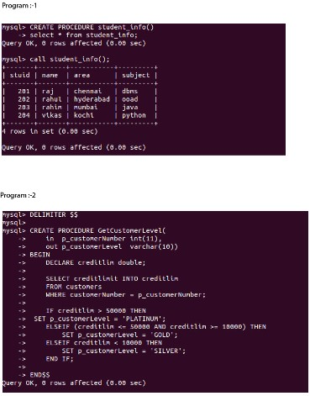

**Program 2:**

Create a stored procedure GetCustomerLevel() that accepts two parameters customer number and customer level.

First, it gets the credit limit from the customers table.

Then, based on the credit limit, it determines the customer level: PLATINUM , GOLD , an SILVER.



**RESULT:**Thus the program in MySQL executed successfully.